Aseprite Documentation for Command-Line Interface (CLI): <https://www.aseprite.org/docs/cli/>

1. **Setup your batch file with the paths to your local Aseprite files**

Here is my batch file for my local files for example. It will be different on your PC since we installed things and store our files in different places. The simplest way to copy the path of a file is to Hold ‘Shift’ and while you are holding it, Right-Click on the file you want to copy the path from. You will need the paths to the Aseprite executable, and the paths to each of the player’s Aseprite project files.

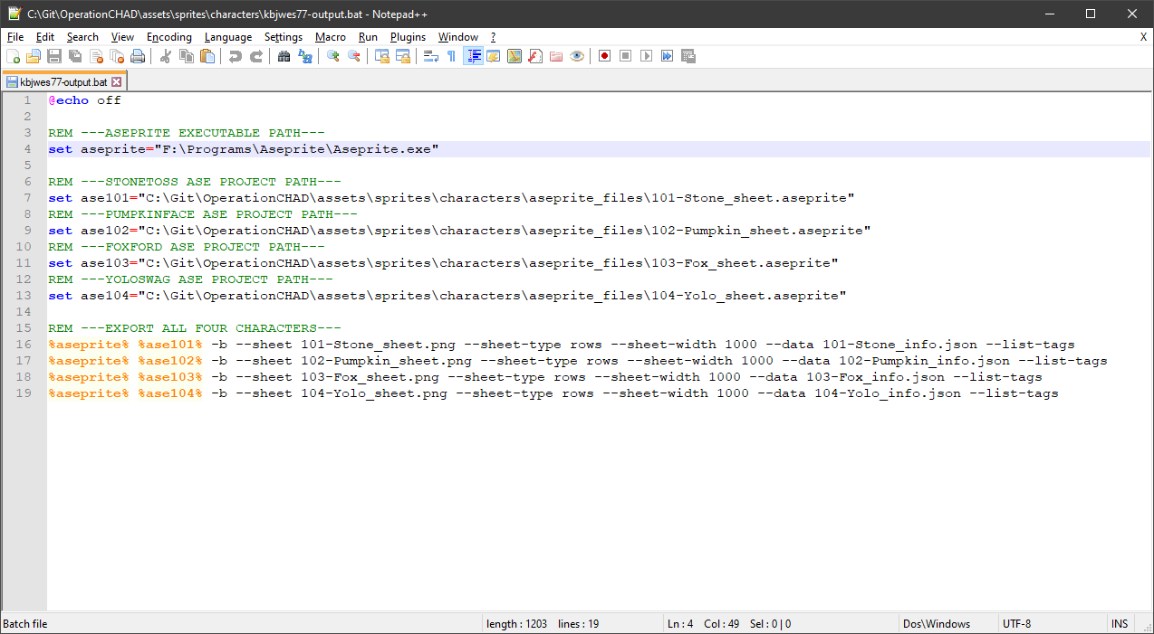

1. **Double click the batch file to output the sprite-sheet/sheet-info files**

This will silently run the code from our batch file and output the PNG files and JSON files for ALL of the project files simultaneously. You can place this batch file anywhere on your PC if you setup the batch with the exact paths to Aseprite and the project files using the method above. *Note: The PNG/JSON files will be created in the same directory as the batch file.*

1. **Zip the PNG/JSON files and drop it into the GameMaker Project**

Select all of the files created by the batch file. Right-Click on the files and select Send To -> Compressed (zipped) Folder. Rename the zip archive to ***“skins.zip”***. If “skins.zip” already exists as an Included File in the GameMaker project, delete it, and drag the new one into the Included Files resource menu.

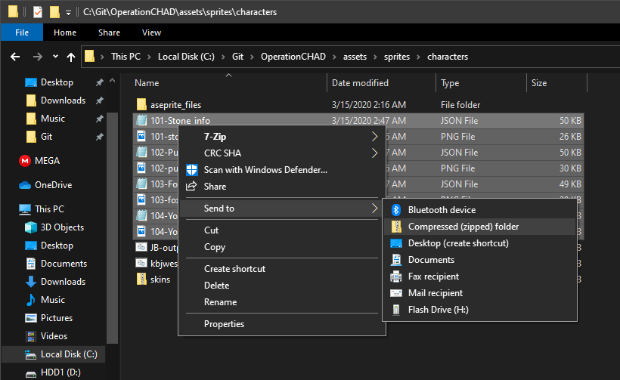

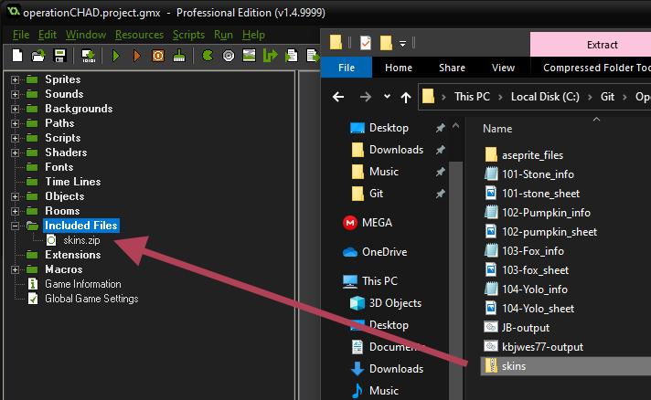

1. **Save the project and compile/run!**

If done correctly, GameMaker should be able to unzip the files at runtime, extract the necessary info from the JSON files, and load the PNG files for the character animations. The expected tags are hardcoded into the GameMaker project, so if any of the tags in the Aseprite project file are changed, the code will need to change to reflect those updates. Otherwise all animations, regardless of size/frame/color changes, will continue to function normally. *Note: If you rename the PNG/JSON files before zipping them, they will not be found by GameMaker, although you can load them manually by pressing ‘F3’.*